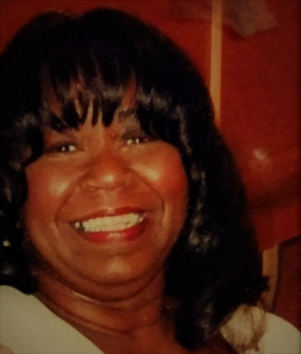

Rita Williams was born into a humanitarian oriented family, and was encouraged to be a humanitarian. Rita has done that by being a:
Volunteer Computer Training at the Metropolitan Community College on behalf of Southwestern Bell Telephone Company.
Volunteer Youth Friend for the Hickman Mills School District.
Volunteer in the Attendance Office at the Hickman Mills High School.
Youth Director at the Mt. Pleasant Missionary Baptist Church.
Former Block-watch Captain at the Fairlane Home Association.
Former Regional Director of the Missouri State PTA-Three Trails.
Former President of the Hickman Mills High School Parents Teacher Student Association (PTSA).
Former 1st Vice President of the Hawks Ridge Home Association.
Former CWA Union Leader.

