JIM THE WONDER DOG: MOONSTRUCK IN MARSHALL; 1:15 P M, IN THE LIGHT OF TOTAL SOLAR ECLIPSE 2017.

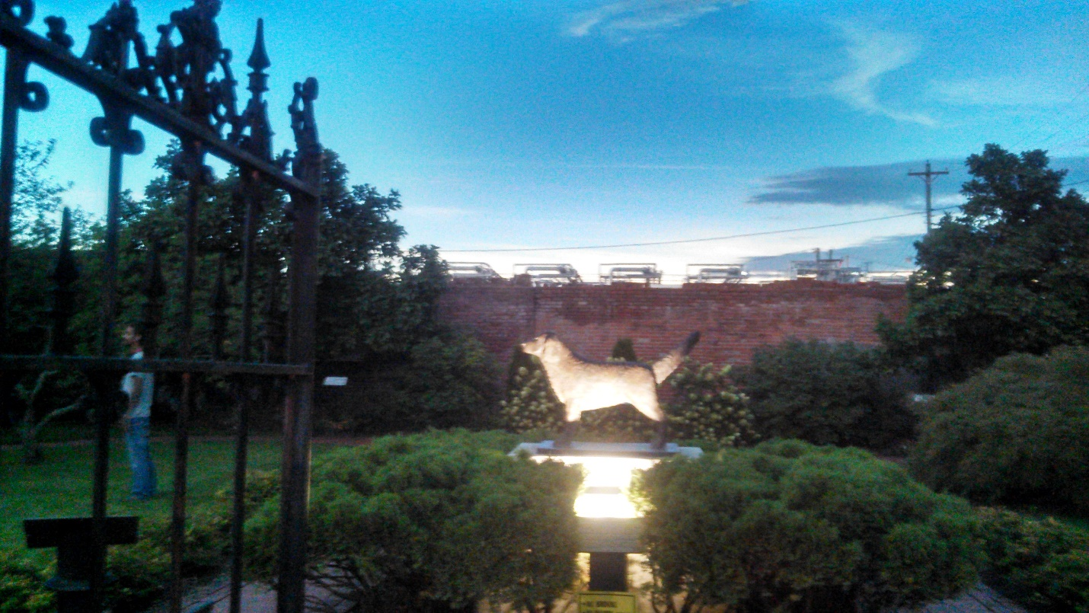

The T J W Family Charitable Foundation’s website is https://www.tjwfamilycharitablefoundation.org
Accept this as our token of appreciation for your thoughts of a donation to help us financially. This is a picture of Jim the Wonder Dog, the State of Missouri’s “Wonder Dog” by proclamation. Google Jim the Wonder Dog to find out how he got his title?
Please feel free to send us any concerns that you feel people need to be doing to help one another to rise in this land of opportunity? Feel free to volunteer some time, where you are, to find out where the various places are that help the homeless, and or low-to middle income, and or stranded people so that we can put info together and make it available for their use as they move from place to place.
We are grassroots people who are just getting started, grassroots people who have had enough of the way that things are going, and we are reaching out to kindred spirits to make this world a better place. The Moon’s Shadow could be the start of a bright new day, for those who choose to make it that way.
HELP US TO HELP OTHERS? DONATE WHAT YOUR HEART WILL ALLOW YOU TO, AS OFTEN AS YOU PLEASE. And THANK YOU! Tadar, Founder, T J W Family Charitable Foundation

